
Module Title
Principles of Programming
Weekly Assignment - Practical 3
Year
2025

Student Name: NIRVIK K.C.
UWE ID: 25024649
Assignment Submission Date: January 3, 2026

1
25024649

This assignment consists of the programming questions from practical exercises related to the topics from week 3.

Questions
- Write, compile and run a C program to read from an input file.
Given code :
/* read values from input file Practical 3, Part 2
@author your name */
#include FILE *fp;
// define a file pointer for the file to hold a disk location
int main()
{
// open the file and assign its address/disk location to file pointer
fp = fopen("inputFile.txt", "r"); //relative pathname used
// add rest of program here – use fp for the file
fclose (fp); // always close files you've opened
}

2
25024649
Answer:
Step 1: Create a folder(practical3) to store the program in this practical.
Step 2: Create a text file(inputFile.txt).
Step 3: Use the text file(inputFile.txt) as input file.
Step 4: Reading from the input file.
Step 5: Run the program

Following code for input:
/* read values from input file
Practical 3, Part 1 (a)
@Nirvik K.C. */

#include <stdio.h>
FILE *fp; // define a file pointer for the file to hold a disk location
int main()
{

3
25024649
// open the file and assign its address/disk location to file pointer
fp = fopen("inputFile.txt", "r"); // relative pathname used
// declare variables for holding the values of input
char firstWord[20];
char secondWord[20];
int num;
printf("Reads two words and an integer from file \n");
// Read two words and an integer from file
// fscanf instead of scanf used, and file pointer needed
fscanf(fp, "%s %s %d", firstWord, secondWord, &num);
// display two words and an integer
printf("Displays back what has been read from input file:\n");
printf("%s %s \n%d \n", firstWord, secondWord, num);
fclose(fp); // Closes the file
return 0;
}

4
25024649
/* Output :
Reads two words and an integer from file
Displays back what has been read from input file:
Hello World
4
*/

Output obtained in execution:
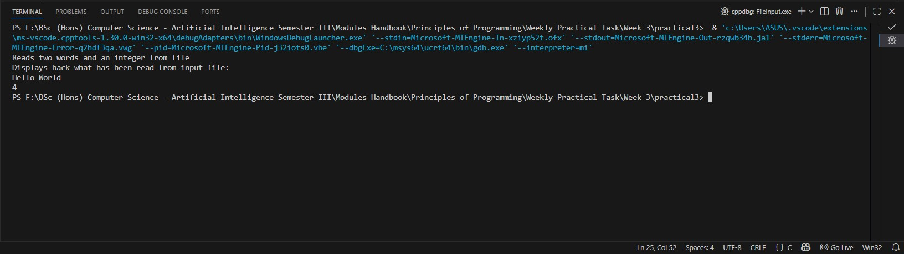
5

25024649
- (b) Change the layout of the values in the input file with the three input values on the same line and check whether your program still works.
Answer:
Following code for input:
/* read values from input file
Practical 3, Part 1 (b)
@Nirvik K.C. */

#include <stdio.h>
FILE *fp; // define a file pointer for the file to hold a disk location
int main()
{
FILE *fp;
// open file for reading
fp = fopen("inputFile.txt", "r");
if (fp == NULL)
{
{
printf("Error opening the file");
return 1;
}
}
6
25024649
// declare variables for holding the values of input
char firstWord[20];
char secondWord[20];
int num;
printf("Reads two words and an integer from file \n");
// Changed the layout of the values in the input file - Hello World 4
// Read two words and an integer from file
fscanf(fp, "%s %s %d", firstWord, secondWord, &num);
// Display two words and an integer
printf("Displays back what has been read from input file:\n");
printf("%s %s %d \n \n", firstWord, secondWord, num); // Display the three input values on the same line
fclose(fp); // Closes the file
return 0;
}
/* Output :
Reads two words and an integer from file
Displays back what has been read from input file:
Hello World 4
*/

7
25024649
Output obtained in execution:
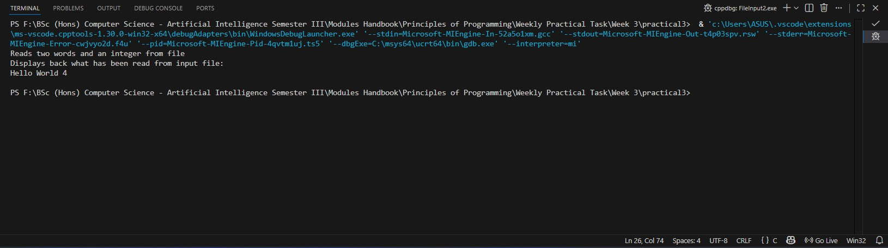

- Create a text file and save it in the practica3 folder. Name the file as bill_input.txt, which contains one set of input values only as follows:
900 800 23 5
Save ElectricityBillA.c in the practical2 folder as ElectricityBillB.c in the same folder. Program should read the input data from input file billInput.txt instead of reading the input data from the keyboard. Add a loop into your program so that your program will run only once by looping through the 7 sets of values.

8
25024649
Given code:
//loop begins
for (int i = 1; i <= 7; i++)
{
//Adapt the existing block of code for reading and validating one set of input values (i.e. use fscanf with a file pointer)
} //loop ends
Update the input file, bill_input.txt, with the following input data, save it, run it, and test it :
900 800 23 5
9000 9999 12 2
9999 10005 14 6
500 6000 26 7
10000 10100 10 9
6000 6890 30 2
590 829 31 9

Answer:
Following code for input:
/* read values from input file
Practical 3, Part 2
@Nirvik K.C. */
9
25024649
#include <stdio.h>
FILE *fp; // define a file pointer for the file to hold a disk location
int main()
{
// open file for reading
fp = fopen("bill_input.txt", "r");
if (fp == NULL)
{
printf("Error opening the file");
return 1;
}
// Declare variables to store input values
int previous, current, day, month;
int units;
printf("Starting validation of electricity bill readings from the file\n\n");
// Loop to read set of input values from the file
for (int i = 1; i <= 7; i++)

10
25024649
{
printf("The Electricity Bill Set %d\n", i);
fscanf(fp, "%d %d %d %d", &previous, &current, &day, &month);
// Display the read values
printf("Input read: Previous Reading= %d, Current Reading= %d, Day= %d, Month= %d\n", previous, current, day, month);
// Validation checks
if (current < 0 || current > 9999)
{
printf("Error: Current meter reading out of range (0-9999)\n");
}
if (previous < 0 || previous > 9999)
{
printf("Error: Previous meter reading out of range (0-9999)\n");
}

11
25024649
if (current - previous > 1000)
{
printf("Error: Electricity used more than 1000 units\n");
}

if (previous > current)
{
printf("Error: Previous reading is greater than current reading\n");
}

if (month < 1 || month > 12)
{
printf("Error: Month out of range (1-12)\n");
}
// Check days in month
if ((month == 1 || month == 3 || month == 5 || month == 7 || month == 8 || month == 10 || month == 12) && (day < 1 || day > 31))

12
25024649
{
printf("Error: Day out of range for the given month (1-31)\n");
}
if ((month == 4 || month == 6 || month == 9 || month == 11) && (day < 1 || day > 30))
{
printf("Error: Day out of range 1 to 30\n");
}
if (month == 2 && (day < 1 || day > 29))
{
printf("Error: Day out of range 1 to 29\n");
}
printf("\n");
}
fclose(fp); // Closes the file
return 0;
}

13
25024649
/* Output :
Starting validation of electricity bill readings from the file
The Electricity Bill Set 1
Input read: Previous Reading= 900, Current Reading= 800, Day= 23, Month= 5
Error: Previous reading is greater than current reading
The Electricity Bill Set 2
Input read: Previous Reading= 9000, Current Reading= 9999, Day= 12, Month= 2
The Electricity Bill Set 3
Input read: Previous Reading= 9999, Current Reading= 10005, Day= 14, Month= 6
Error: Current meter reading out of range (0-9999)
The Electricity Bill Set 4
Input read: Previous Reading= 500, Current Reading= 6000, Day= 26, Month= 7
Error: Electricity used more than 1000 units
The Electricity Bill Set 5
Input read: Previous Reading= 10000, Current Reading= 10100, Day= 10, Month= 9
Error: Current meter reading out of range (0-9999)
Error: Previous meter reading out of range (0-9999)
14
25024649
The Electricity Bill Set 6
Input read: Previous Reading= 6000, Current Reading= 6890, Day= 30, Month= 2
Error: Day out of range 1 to 29
The Electricity Bill Set 7
Input read: Previous Reading= 590, Current Reading= 829, Day= 31, Month= 9
Error: Day out of range 1 to 30
*/
Output obtained in execution: 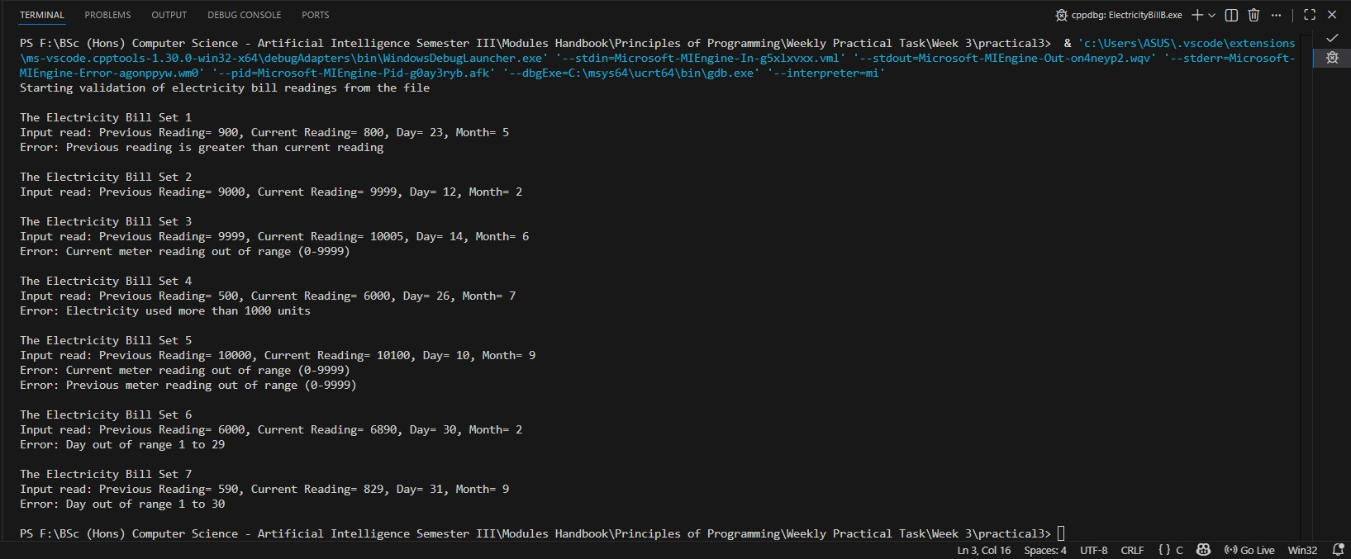
15
25024649
- An electricity company keeps the metre readings of their customers in a text file, which should consist of an integer (which is the number of lines in the file) followed by a series of lines each of which consists of a customer number, the previous metre reading and the current metre reading (separated by a space). A program is required to take the text file as an input file, read a set of input values from the input file at a time, calculate the number of units the customer has used over the period, classify the user as follows:

Above 1000 units – heavy user
500 – 1000 units – regular user
Below 500 units – light user
The program should produce statistics for each category of users and display the statistics on the screen.

For example,
Heavy users 20
Regular users 105
Light users 54

Step 1: Create a text file named testInput.txt, and save it to the practical3 folder. The text file should contain following input data:

16
25024649
5
1078 9000 9999
1234 10000 10100
1134 6000 6890
4511 590 829
8122 500 2000

Step 2: Now, create a C program named CustomerStatistics.c in the same folder. Step 3: Also, produce a program outline/pseudocode before creating the C program.
Step 4: Write the C program to implement your program outline.
Step 5: Run and test your program.

17
25024649
Answer:
Following pseudocode:
START
Open testInput.txt for reading
IF file cannot be opened
Display "Error: Cannot open file testInput.txt"
Stop program
END IF
Read number_of_customers from file
Set heavyCount = 0
Set regularCount = 0
Set lightCount = 0
FOR i = 1 to number_of_customers
Read customer_number, previous_reading, current_reading
unitsUsed = current reading - previous reading
IF unitsUsed > 1000
heavyCount = heavyCount + 1

18

25024649
ELSE IF unitsUsed >= 500
regularCount = regularCount + 1
ELSE
lightCount = lightCount + 1
END FOR

Following code for input:
/* read values from input file
Practical 3, Part 3
@Nirvik K.C. */

#include <stdio.h>
int main()
{
FILE *fp;
int total_customers, customer_num, previous_read, current_read;
int units_used;
19
25024649
int heavy_users = 0;
int regular_users = 0;
int light_users = 0;
fp = fopen("testInput.txt", "r");
if (fp == NULL)
{
printf("Error opening the file");
return 1;
}
fscanf(fp, "%d", &total_customers);
int i;
for (i = 0; i < total_customers; i++)
{
fscanf(fp, "%d %d %d", &customer_num, &previous_read, &current_read);
units_used = current_read - previous_read;

20
25024649
if (units_used > 1000)
{
heavy_users++;
}
else if (units_used >= 500)
{
regular_users++;
}
else if (units_used < 500)
{
light_users++;
}
else
{
printf("Meter reading error for customer %d\n", customer_num);
}
}

21

25024649
printf("Customer Electricity Usage Statistics:\n");
printf("Heavy users: %d\n", heavy_users);
printf("Regular users: %d\n", regular_users);
printf("Light users: %d\n", light_users);

fclose(fp);
return 0;
}
/* Output:
Customer Electricity Usage Statistics:
Heavy users: 1
Regular users: 2
Light users: 2
*/

22
25024649
Output obtained in execution:
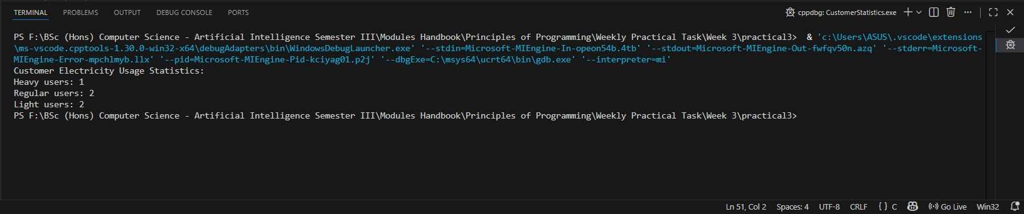

- More Programming exercises
Use nested loops that display the following patterns in four separate programs:
4. (a) Display Pattern A:
1
1 2
1 2 3
1 2 3 4
1 2 3 4 5
1 2 3 4 5 6
23
25024649
Answer:
Following code for input:
/* read values from input file
Practical 3, Part 4 - 3.1, Display Pattern A
@Nirvik K.C. */

#include <stdio.h>
int main()
{
int i, j, rows;
// Prints number of lines (rows of numbers)
printf("\nEnter the number of rows: ");
scanf("%d", &rows);
for (int i = 1; i <= rows; i++) // for number of rows
{
for (int j = 1; j <= i; j++) // for printing numbers in each row

24
25024649
{
printf("%d ", j);
}
printf("\n"); // go to next line after printing each row
}
return 0;
}

Output obtained in execution:
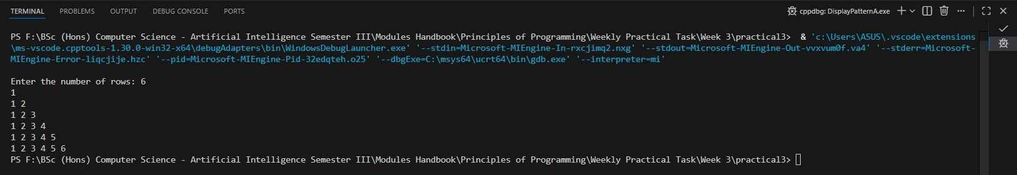

25
25024649
4. (b) Display Pattern B
1 2 3 4 5 6
1 2 3 4 5
1 2 3 4
1 2 3
1 2
1

Answer:
Following code for input:
/* read values from input file
Practical 3, Part 4 - 3.1, Display Pattern B
@Nirvik K.C. */
#include <stdio.h>
int main()
{
int i, j, rows;
// Prints number of lines (rows of numbers)
26
25024649
printf("\nEnter the number of rows: ");
scanf("%d", &rows);
for (i = rows; i >= 1; i--) // for number of rows
{
for (j = 1; j <= i; j++) // for printing numbers from 1 to current row value (i)
{
printf("%d ", j);
}
printf("\n"); // go to next line after printing each row
}
return 0;
}
Output obtained in execution:
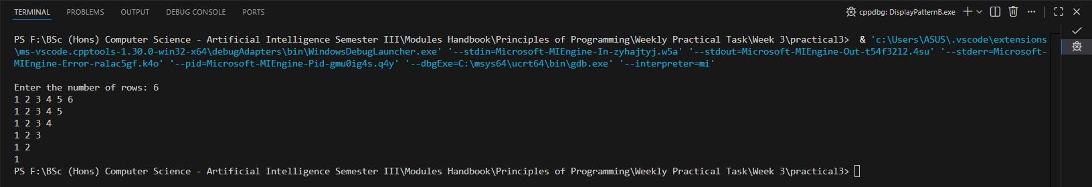
27
25024649
- (c) Display Pattern C
1
2 1
3 2 1
4 3 2 1
5 4 3 2 1
6 5 4 3 2 1
Answer:
Following code for input:
/* read values from input file
Practical 3, Part 4 - 3.1, Display Pattern C
@Nirvik K.C. */
#include <stdio.h>
int main()
{
int rows;
int i, j, k;
printf("Enter the number of rows: ");
scanf("%d", &rows);
28
25024649
for (int i = 1; i <= rows; i++)
{
for (int j = 1; j <= (rows - i); j++) // calculating spaces
{
printf(" "); // printing two spaces
}
// Print descending numbers from i to 1
for (int k = i; k >= 1; k--)
{
printf("%d ", k);
}
printf("\n"); // go to next line after printing each row
}
return 0;
}

29

25024649
Output obtained in execution:
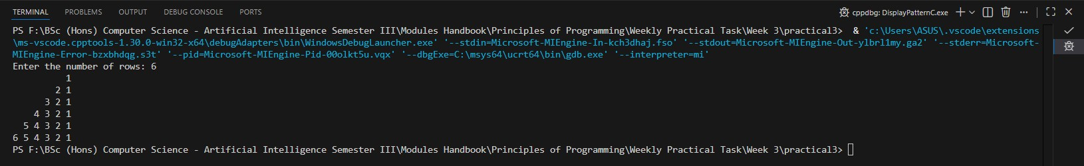

- (d) Display Pattern D
1 2 3 4 5 6
1 2 3 4 5
1 2 3 4
1 2 3
1 2
1

Answer:
Following code for input:
30
25024649
/* read values from input file
Practical 3, Part 4 - 3.1, Display Pattern D
@Nirvik K.C. */

#include <stdio.h>
int main()
{
int rows;
printf("Enter the number of rows: ");
scanf("%d", &rows);
for (int i = rows; i >= 1; i--) // for number of rows
{
for (int j = 1; j <= (rows - i); j++) // calculating spaces
{
printf(" "); // printing two spaces
}
// Print descending numbers from i to 1

31
25024649
for (int k = 1; k <= i; k++)
{
printf("%d ", k);
}
printf("\n"); // go to next line after printing each row
}
return 0;
}

Output obtained in execution:
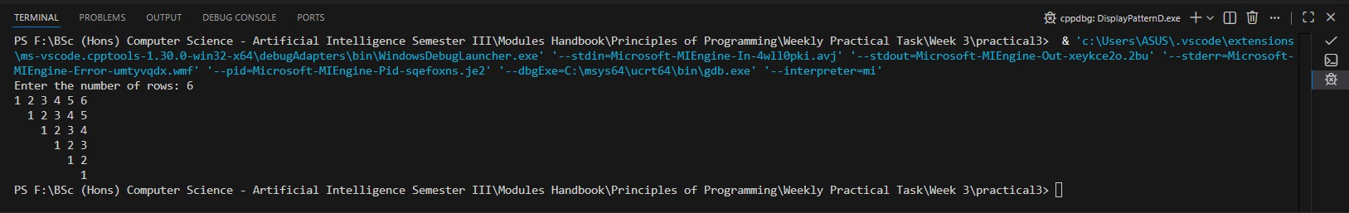

32
25024649
- (Occurrence of max numbers) Write a program that reads integers, finds the largest of them, and counts its occurrences. Assume that the input ends with number 0. Suppose that you entered 3 5 2 5 5 5 0; the program finds that the largest is 5 and the occurrence count for 5 is 4.

Answer:
Following code for input:
/* read values from input file
Practical 3, Part 4 - 3.2 (Occurrence of max numbers)
@Nirvik K.C. */
#include <stdio.h>
int main()
{
int num;
int number;
int max;
int count = 0;
33
25024649
printf("Enter numbers (type 0 to stop):\n");
// Read the first number
scanf("%d", &number);
while (number != 0)
{
if (number > max)
{
max = number;
count = 1; // starting a new count
}
else if (number == max)
{
count++;
}

34
25024649
scanf("%d", &number); // Read the next number
}
// Display the maximum number and its occurrence after 0 is entered at last
if (max == 0)
{
printf("No numbers were entered.\n");
}
else
{
printf("The largest number is %d.\n", max);
printf("The occurrence of the largest number is %d times.\n", max, count);
}
return 0;
}

35
25024649
/* Output:
Enter numbers (type 0 to stop):
3 5 2 5 5 5 0
The largest number is 5.
The occurrence of the largest number is 5 times.*/

Output obtained in execution:
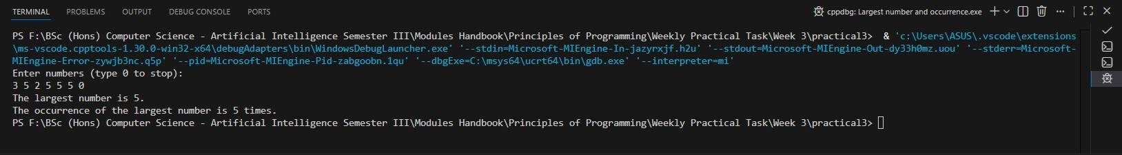

36
25024649
- (Count vowels and consonants) Assume letters A, E, I, O, and U as the vowels. Write a program that prompts the user to enter a string and displays the number of vowels and consonants in the string.
Output to display:
Enter a string: Programming is fun
The number of vowels is 5
The number of consonants is 11

Answer:
Following code for input:
/* read values from input file
Practical 3, Part 4 - 3.3 (Count vowels and consonants)
@Nirvik K.C. */

37
25024649
#include <stdio.h>
#include <string.h>
int main()
{
char str[100];
int vowels = 0, consonants = 0;
int i, j;
char vowel_list[10] = {'A', 'E', 'I', 'O', 'U', 'a', 'e', 'i', 'o', 'u'};

printf("\nEnter a string: ");
// To read the whole line including spaces
fscanf(stdin, "%[^\n]", str); // using %[^\n] to read string with spaces
for (int i = 0; i < strlen(str); i++)
{
char ch = str[i];

38
25024649
// Check if the character is a letter (A-Z or a-z)
if ((ch >= 'A' && ch <= 'Z') || (ch >= 'a' && ch <= 'z'))
{
int isVowel = 0;
for (int j = 0; j < 10; j++)
{
if (ch == vowel_list[j])
{
isVowel = 1;
break;
}
}
if (isVowel)
{
vowels = vowels + 1;
}

39
25024649
else
{
consonants = consonants + 1;
}
}
}
printf("The number of vowels is %d\n", vowels);
printf("The number of consonants is %d\n", consonants);
return 0;
}

/* Output:
Enter a string: Programming is fun
The number of vowels is 5
The number of consonants is 11 */

40
25024649
Output obtained in execution:
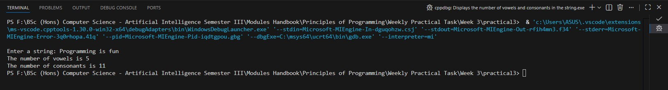

41

